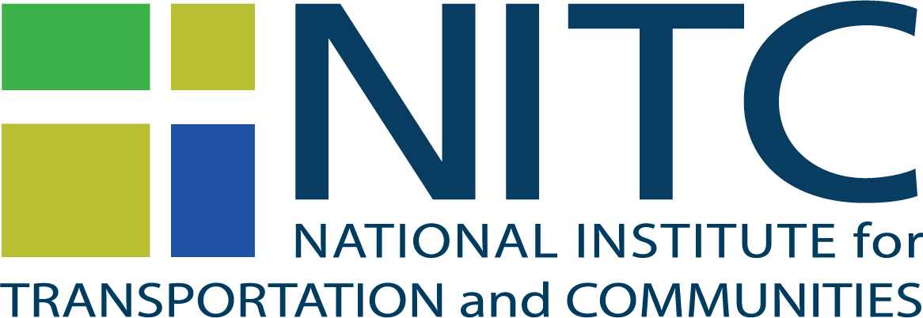
International Travel Request

PIs and students can request to use NITC funds to present research at an international conference. There is a cost-share match requirement. Submit this form to Brendan Williams (brendan.williams@pdx.edu) 6 weeks in advance of travel. Note that requests submitted after travel WILL NOT be approved.
- Describe specific reason for travel including dates, and the value to be gained by the NITC grant program:

- Name and relationship of traveler to the NITC grant:

- Describe how the travel will further the goals of the NITC program:

- Provide detailed itinerary & breakdown of planned expenses, including NITC and other funds:

- Endorsement of Center Director:

