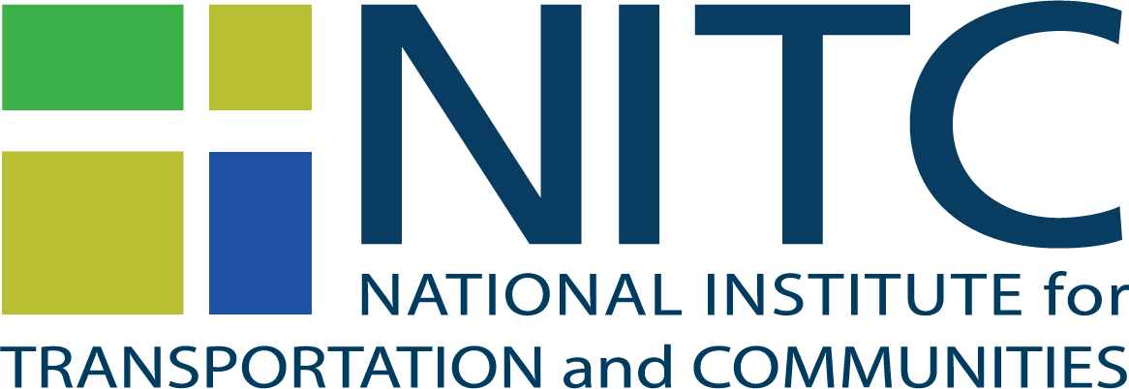 | Request for Proposals  Doctoral Dissertation Research Fellowships

Overview
The National Institute for Transportation and Communities (NITC) invites proposals for its Doctoral Dissertation Research Fellowships. This grant is part of the University Transportation Center (UTC) program funded by the U.S. Department of Transportation’s (U.S.DOT), and is a partnership between Portland State University, Oregon Institute of Technology, University of Arizona, University of Oregon, University of Texas at Arlington and University of Utah. The mission of the UTC program is to advance U.S. technology and expertise in the many disciplines comprising transportation through the mechanisms of education, research and technology transfer at university-based centers. See utc.dot.gov for more information.
Fellowships up to $15,000 will be awarded to cover expenses for the recipient while working on their dissertation. NITC is focused on contributing to transportation projects that support innovations in:
Improving mobility of people and goods to build strong communities

Eligibility
- Students must be a US Citizen or permanent resident of the U.S. and have advanced to candidacy for the Ph.D. degree prior to the application deadline.
- NITC fellowships are open to students currently enrolled in a transportation-related doctoral program at Portland State University (PSU), Oregon Institute of Technology (Oregon Tech), University of Arizona (UA), University of Oregon UO), University of Texas at Arlington (UTA) and University of Utah (UU).

Successful doctoral dissertation research fellowship proposals will combine advanced research with applied projects that fit the NITC theme, linking to articulated U.S.DOT priorities specifically mobility.

Theme
The NITC theme connects directly with U.S. DOT’s priority of improving mobility of people and goods to build strong communities. All proposals must be consistent with this theme, as defined below:
- Increasing access to opportunities. Well-connected regions and communities can improve social equity by providing access to jobs, services, recreation and social opportunities. Research should examine barriers to access, including the connections between transportation, land use, and housing. It should look at how to overcome these barriers and improve accessibility, affordability and equity in our communities.
- Improving multi-modal planning and shared use of infrastructure. Improved mobility requires a range of options for moving people and goods. As concepts of mobility evolve, research is needed to understand how people and firms make mode choices so that we can design better multi-modal systems. Research should examine how different modes can share our infrastructure safely. It should look at how cities and regions can better plan for and prioritize multi-modal transportation, integrated with land use.
- Advancing innovation and smart cities. The growth of urban areas of all sizes requires the innovative use of technology and new mobility options. Smart cities research should examine the feasibility of integrating connected and automated technologies in our cities and overcoming the social, political and economic barriers to implementation. This includes ensuring that smart cities improve access for all people and modes.
- Developing data, models, and tools. Our complex transportation system demands better data and tools for decision-making. Research is needed to develop tools to collect and analyze multi-modal data from a variety of sources, aimed at optimizing the use of the system. These new models and tools should examine the implications of changes to the system on a range of outcomes including mobility, economic equity, the environment and health.

How to Apply
- Sign up for an Open Researcher and Contributor ID or ORCID. Please include the ORCID number on your application form.
- Complete all five sections of the dissertation application form and compile as a single PDF.
- Complete a Data Management plan (DMP). A DMP guide that includes a DMP template can be found on the NITC website (http://nitc.trec.pdx.edu/for-researchers). Please use the template to generate your DMP.
- If you do not have one, create a user profile for the online proposal and project management system (PPMS) at http://ppms.trec.pdx.edu.
- Submit your application materials to PPMS online.
  - Enter your Dissertation Title
  - Select the “NITC Dissertation Fellowships 2022” grant cycle.
  - Enter your project abstract and click on ‘submit.’
  - Continue the application process by uploading your dissertation application form (as the proposal form) and your Data Management plan.
  - Complete the “Individuals Involved” and “Project Info” sections of the online proposal form.
  - Select “Research” as grant type and enter the start and end dates for your project.
  - You are not required to submit an itemized budget as part of the application process, but the system will require you to upload a blank budget file before you can submit your application.
  - Submit your application. Applicants must submit their application package to the online proposal system to qualify for funding.

Successful applicants should intend to complete their dissertation within one year. If you have questions about the application process, please contact Brendan Williams (Brendan.williams@pdx.edu).

SELECTION PROCESS AND CRITERIA FOR AWARD OF FELLOWSHIP
NITC’s Executive Committee will review the applications. Fellowships will be awarded based on the committee’s assessment of the originality and significance of the research topic, the applicant’s overall record of academic and professional accomplishment, and the relevance of the research topic to current issues in transportation as it relates to the NITC theme.

TERMS AND CONDITIONS
- Fellowships are awarded to cover student expenses while working on the dissertation.
- Award recipients must submit bi-annual progress reports.
- Awards are conditional on the student working on the dissertation topic as described in the fellowship application. If the student decides for any reason to change dissertation topics or to terminate doctoral studies, the student must notify TREC (asktrec@pdx.edu) immediately and a pro rata share of the fellowship must be returned.
- Award recipients must provide a paper copy and electronic version in PDF of the dissertation when it is completed.
- Award recipients agree to acknowledge NITC support and include their ORCID in the dissertation itself and in any publications that may stem from it.

Contact Information
For questions about dissertation proposals or the data management plan, please send an email Brendan Williams. Each campus has a representative on NITC’s Executive Committee who can discuss the process:
- Marc Schlossberg, University of Oregon, 541-346-2046, schlossb@uoregon.edu
- Keith Bartholomew, University of Utah, 801-585-8944, bartholomew@arch.utah.edu
- Roger Lindgren, Oregon Institute of Technology, 541-885-1947, roger.lindgren@oit.edu
- Liming Wang, Portland State University, 503-725-5130, lmwang@pdx.edu
- Kristina Currans, University of Arizona, curransk@email.arizona.edu
- Stephen Mattingly, University of Texas, Arlington, 817-272-2859, mattingly@uta.edu
For more information, visit http://nitc.trec.pdx.edu/.

